DriverPass Client Presentation
Tyieshia Hasan-Watson | CS 255 Project Two

Slide 1 DriverPass System Design
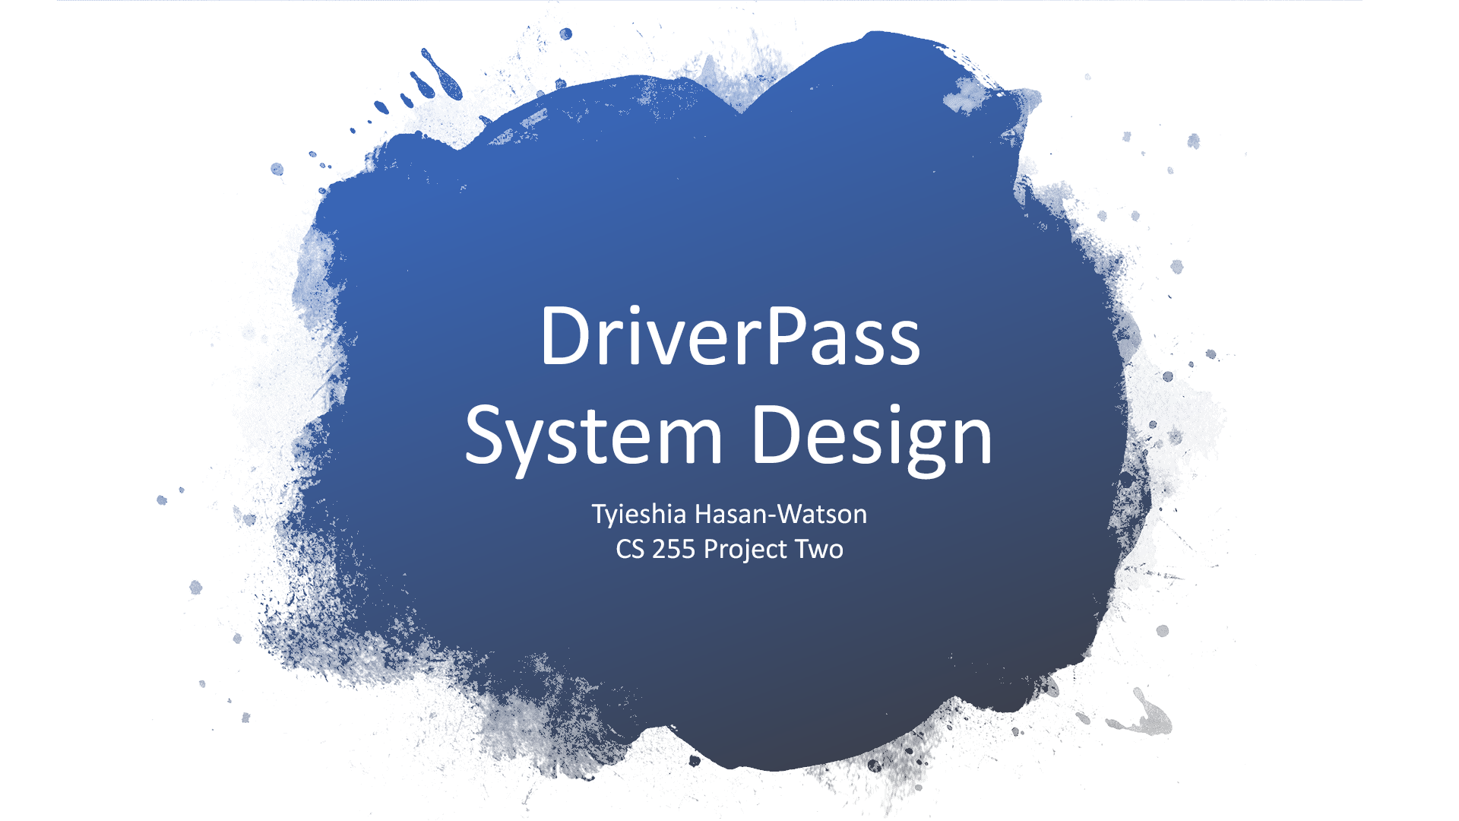

Speaker notes
DriverPass brings driving lessons and learning records together in one online service. This presentation explains the design for Liam and Ian, with a focus on what customers and staff can accomplish. The design follows the DriverPass interview and the business requirements.

DriverPass Presentation Notes

Slide 2 System Requirements
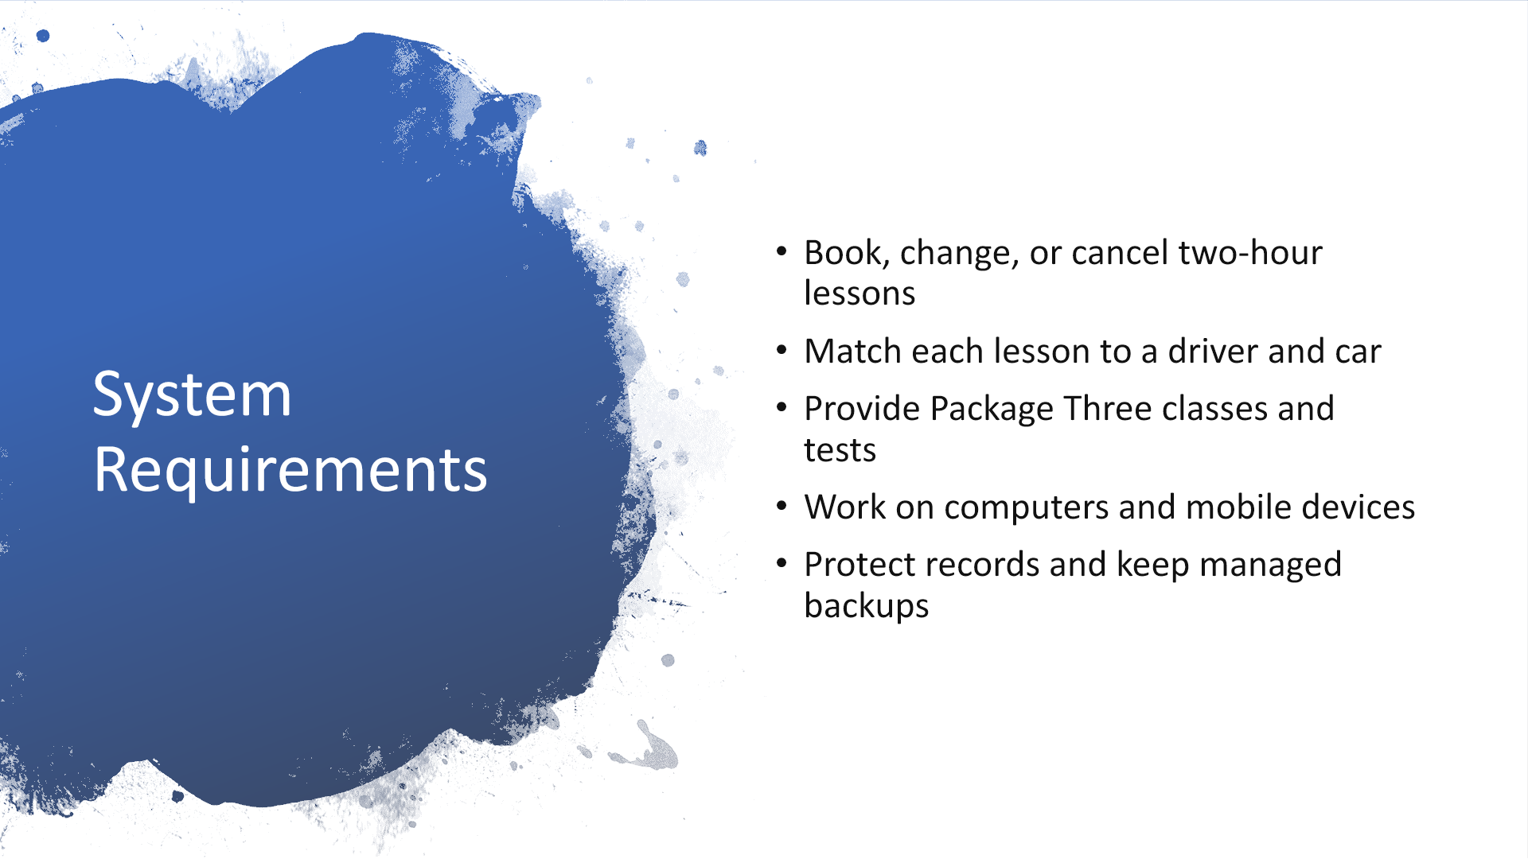

Speaker notes
The service lets customers book, change, or cancel a lesson online. The secretary uses the same schedule when someone calls or visits, so both see the same availability. Every driving lesson lasts two hours and identifies a customer, driver, and car. The initial fleet has ten cars, each paired with a driver. Package One provides six driving hours, or three lessons. Package Two provides eight hours, or four lessons, plus an in-person lesson about DMV rules. Package Three provides twelve hours, or six lessons, the in-person lesson, and the online class and practice tests. Customers can see test names, time taken, scores, and whether tests are not taken, in progress, failed, or passed. The service works through a browser on computers and mobile devices. Managed hosting and tested backups reduce the maintenance burden. DriverPass receives notices about DMV changes and can download reports for use in Excel. Source: DriverPass Interview Transcript, DriverPass Interview section; Project One business requirements, Requirements.

DriverPass Presentation Notes

Slide 3 Use Case Diagram
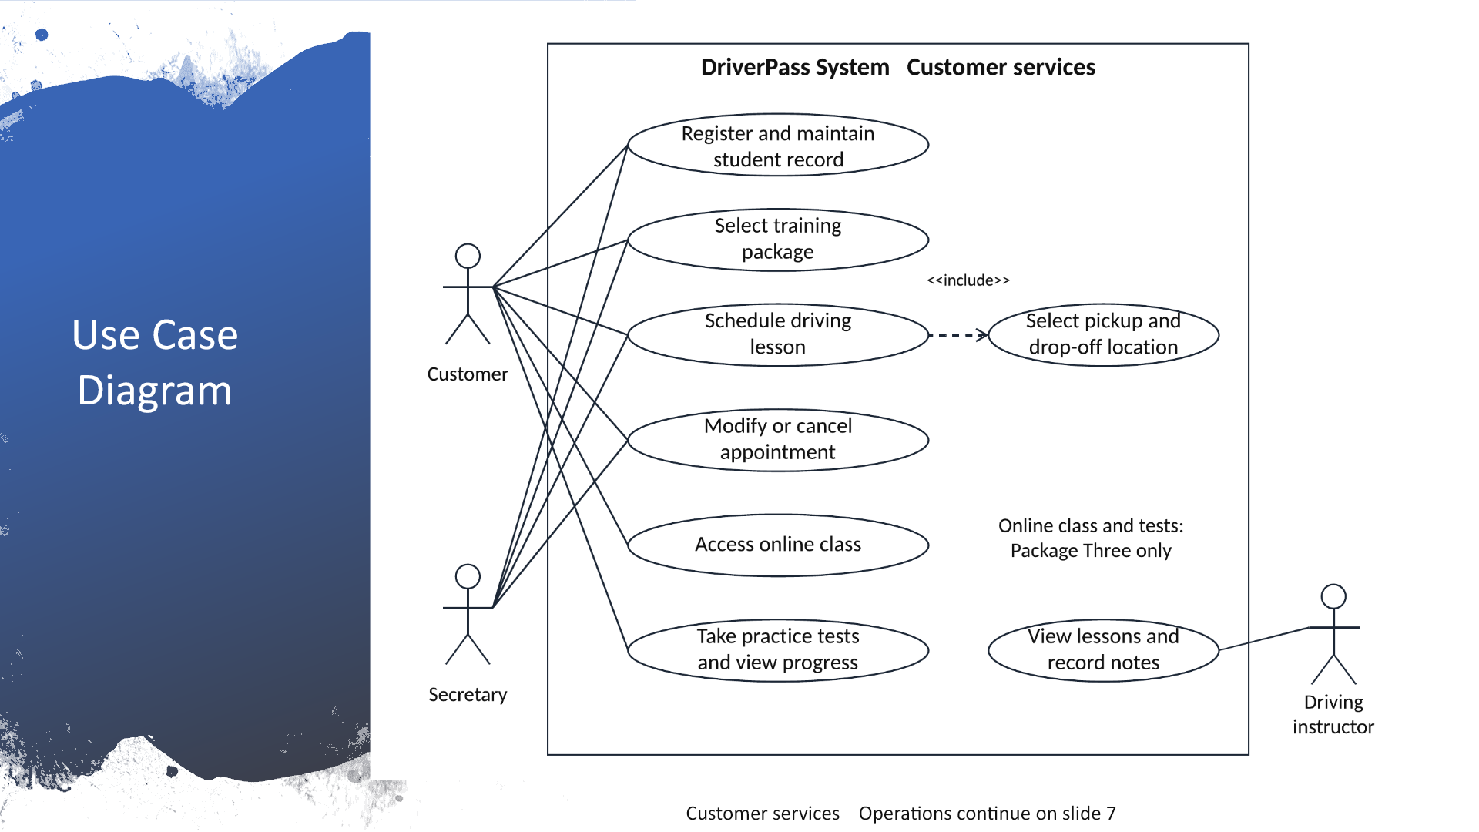

Speaker notes
The people outside the box are the users. The ovals inside show the services they can use. Customers maintain their information, choose a package, and manage their driving appointments. The secretary can help with registration and appointments when a customer calls or visits. Booking always includes choosing a pickup and drop-off location. The drop-off location is the same as the pickup location, as requested in the interview. Drivers see their assigned lessons and enter comments and actual lesson times. We assume drivers enter their own notes, consistent with Project One. Package Three customers can open the online class and take practice tests. The system shows their progress, while the customer record also gives access to lesson notes. The second part of this same diagram appears on slide 7 and covers management and DMV updates. Source: DriverPass Interview Transcript; Project One business requirements; Module Six DriverPass use case diagram. Diagram source: revised UML model imported into Lucidchart, visually verified, and exported from Lucidchart. Editable source: https://lucid.app/lucidchart/a063bc40-1751-4ea4-9f02-ce56344cc82b/edit

DriverPass Presentation Notes

Slide 4 Activity Diagram
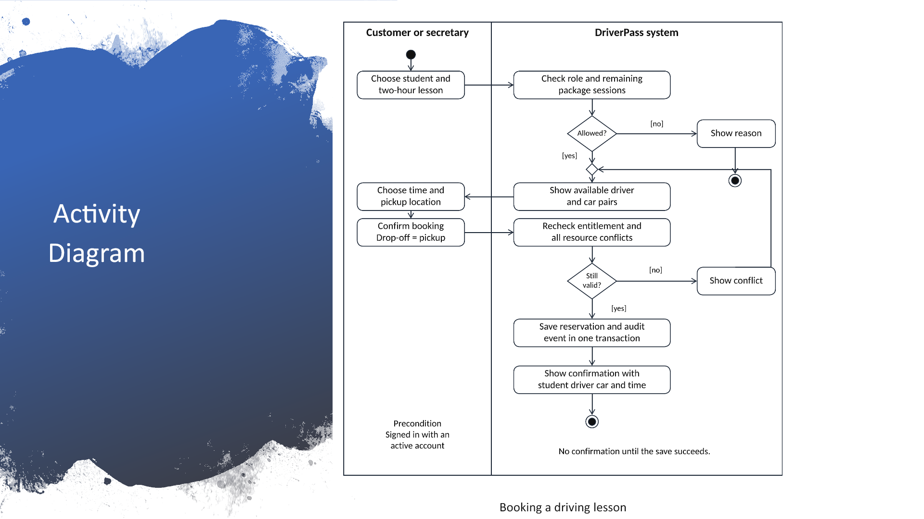

Speaker notes
This picture follows a booking from request to confirmation. The customer, or a secretary helping the customer, chooses a two-hour lesson. The service checks whether the customer has sessions left in the purchased package and shows available driver and car pairs. After the customer chooses a time and pickup location, the service checks again before saving. This second check prevents two people from booking the same driver or car at nearly the same time. If the slot is no longer available, the customer sees refreshed choices. A successful booking records who made it and then shows the confirmed customer, driver, car, and lesson time. Changes and cancellations use the same permission checks and record who acted and when. We keep the previous values so Liam can investigate problems with a printed activity report. Source: DriverPass Interview Transcript, reservations and tracking; Project One business requirements, Functional Requirements. Diagram source: revised UML model imported into Lucidchart, visually verified, and exported from Lucidchart. Editable source: https://lucid.app/lucidchart/a063bc40-1751-4ea4-9f02-ce56344cc82b/edit

DriverPass Presentation Notes

Slide 5 Security
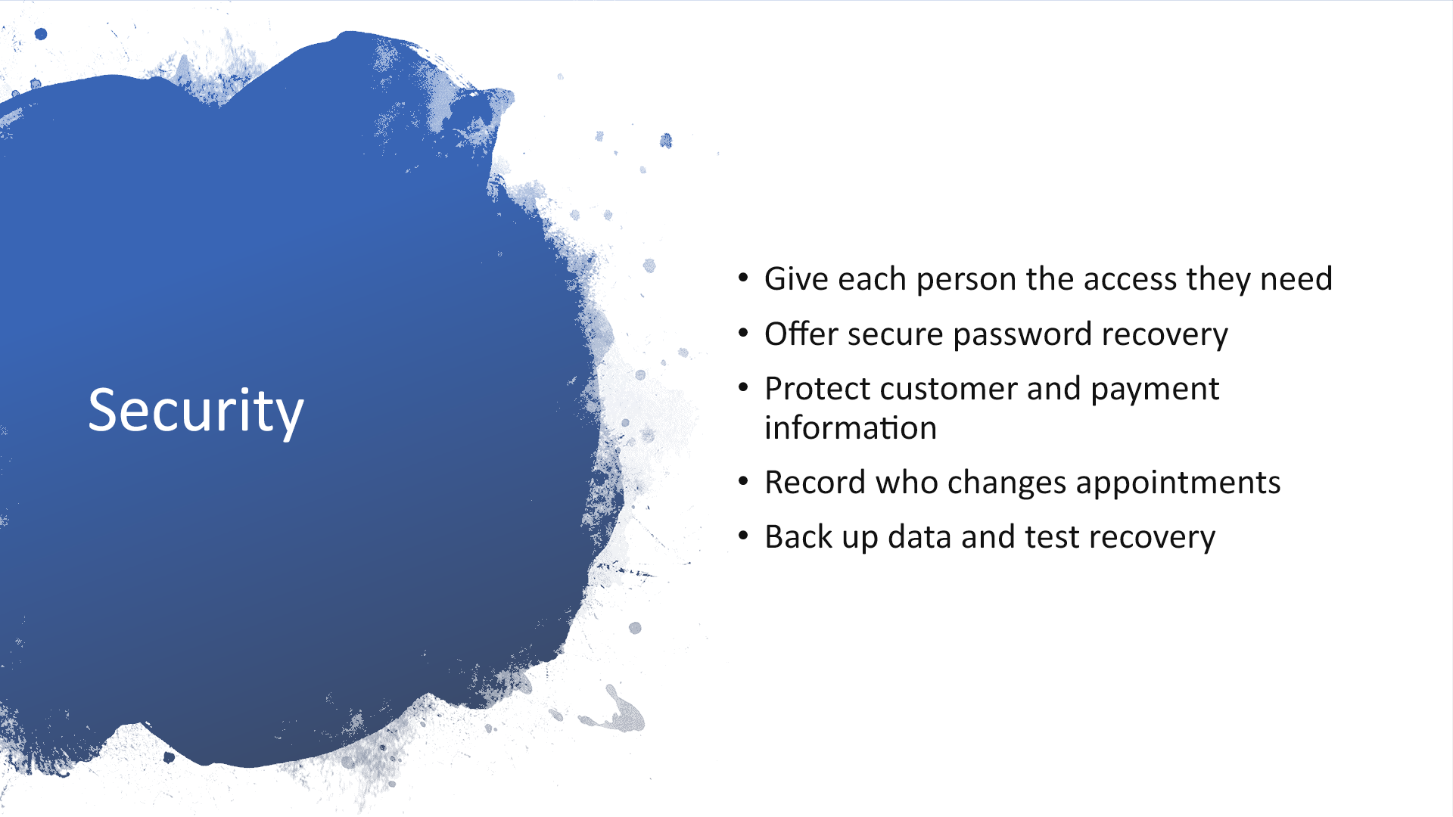

Speaker notes
Customers see their own information. The secretary manages customer records and bookings. Drivers see assigned lessons and enter lesson notes. Liam reviews business activity and can stop new registrations for an existing package. Ian can manage accounts, help reset passwords, and block access when an employee leaves. Customers also have an automatic password-reset option. We propose a verified recovery link that expires and can be used only once. The service protects information while it travels and while it is stored. Our proposed payment design sends card details to a payment provider and keeps only a reference needed for the transaction. It does not retain the card security code. Reservation history records who created, changed, or canceled a booking. Managed backups help recover information, but Ian still reviews access and checks that recovery works. Source: DriverPass Interview Transcript, security and tracking; Project One business requirements, Security. Recovery and payment mechanisms are proposed design choices.

DriverPass Presentation Notes

Slide 6 System Limitations
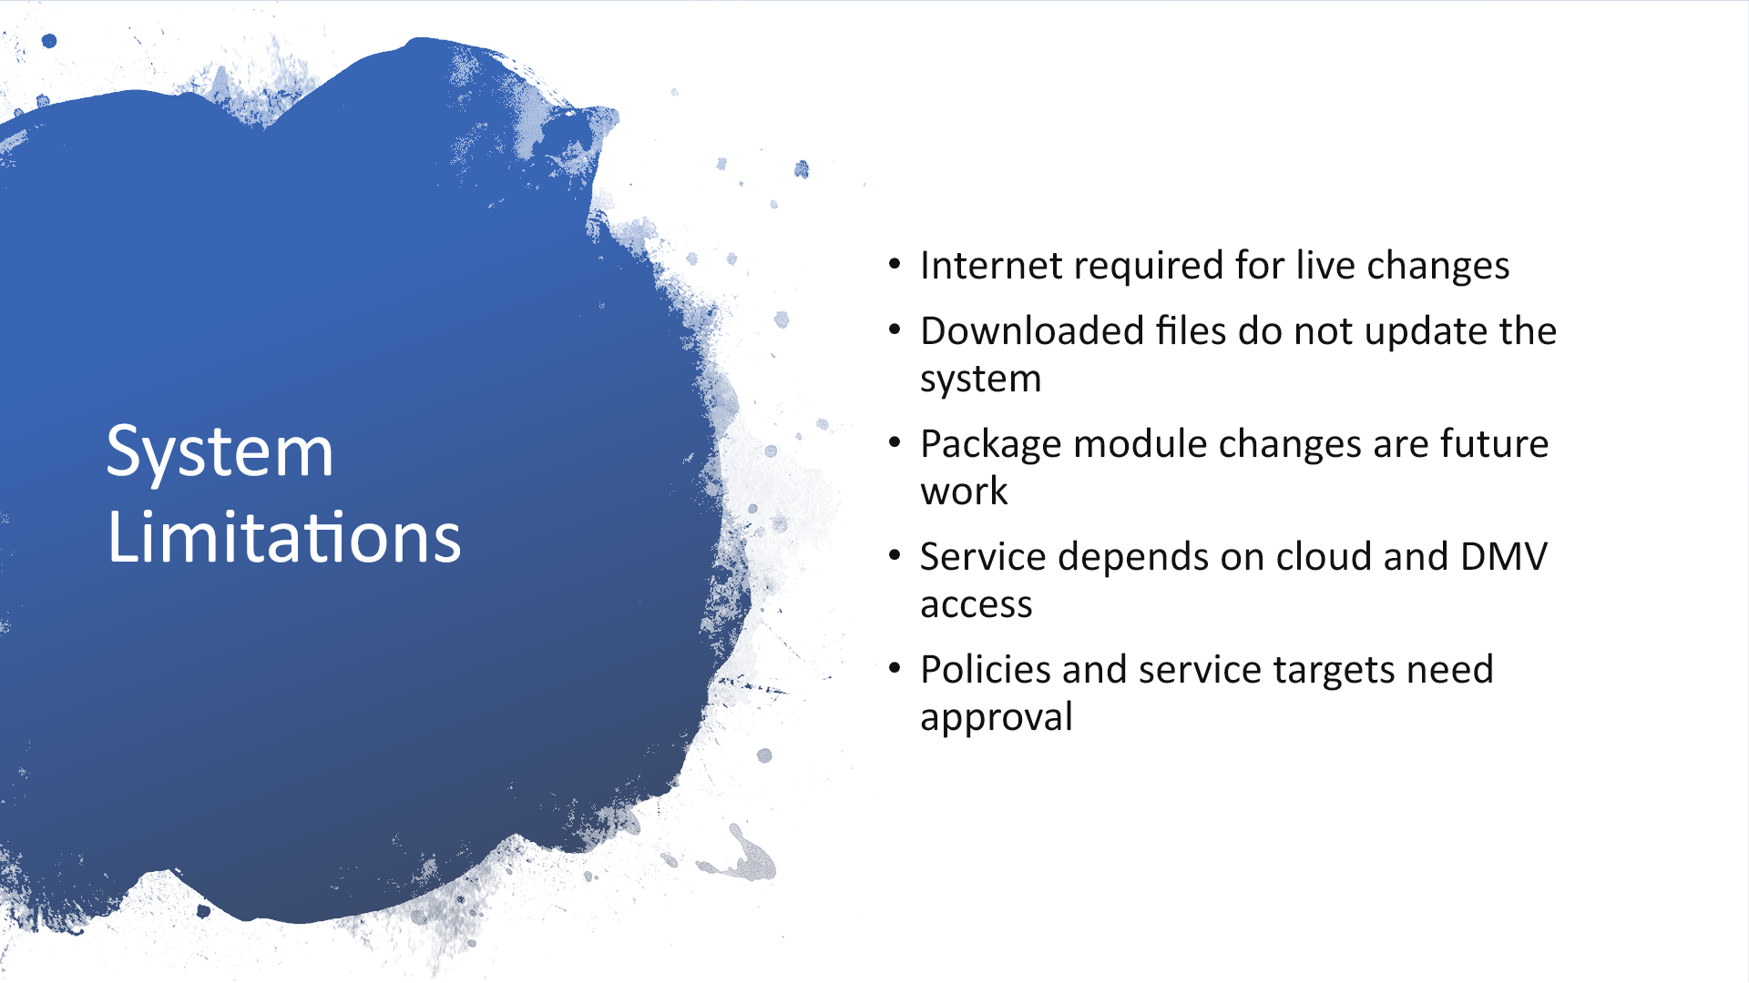

Speaker notes
Customers and staff must be online to change records or take a practice test. Liam can download reports and work with them in Excel while offline, but changes to those files do not update DriverPass. This prevents competing copies of the schedule. Liam can disable an existing package for new registrations. Adding or removing package modules remains a future release that needs developer work. Internet outages, cloud outages, and interruptions to the DMV connection can affect service. The DMV connection method and content review process need agreement before implementation. We also need approval of the cancellation policy, test passing score, backup retention, and expected response times. The design helps customers prepare, but it cannot guarantee a DMV passing result. Source: DriverPass Interview Transcript, offline access and future scope; Project One business requirements, Assumptions and Limitations.

DriverPass Presentation Notes

Slide 7 Use Case Diagram continued
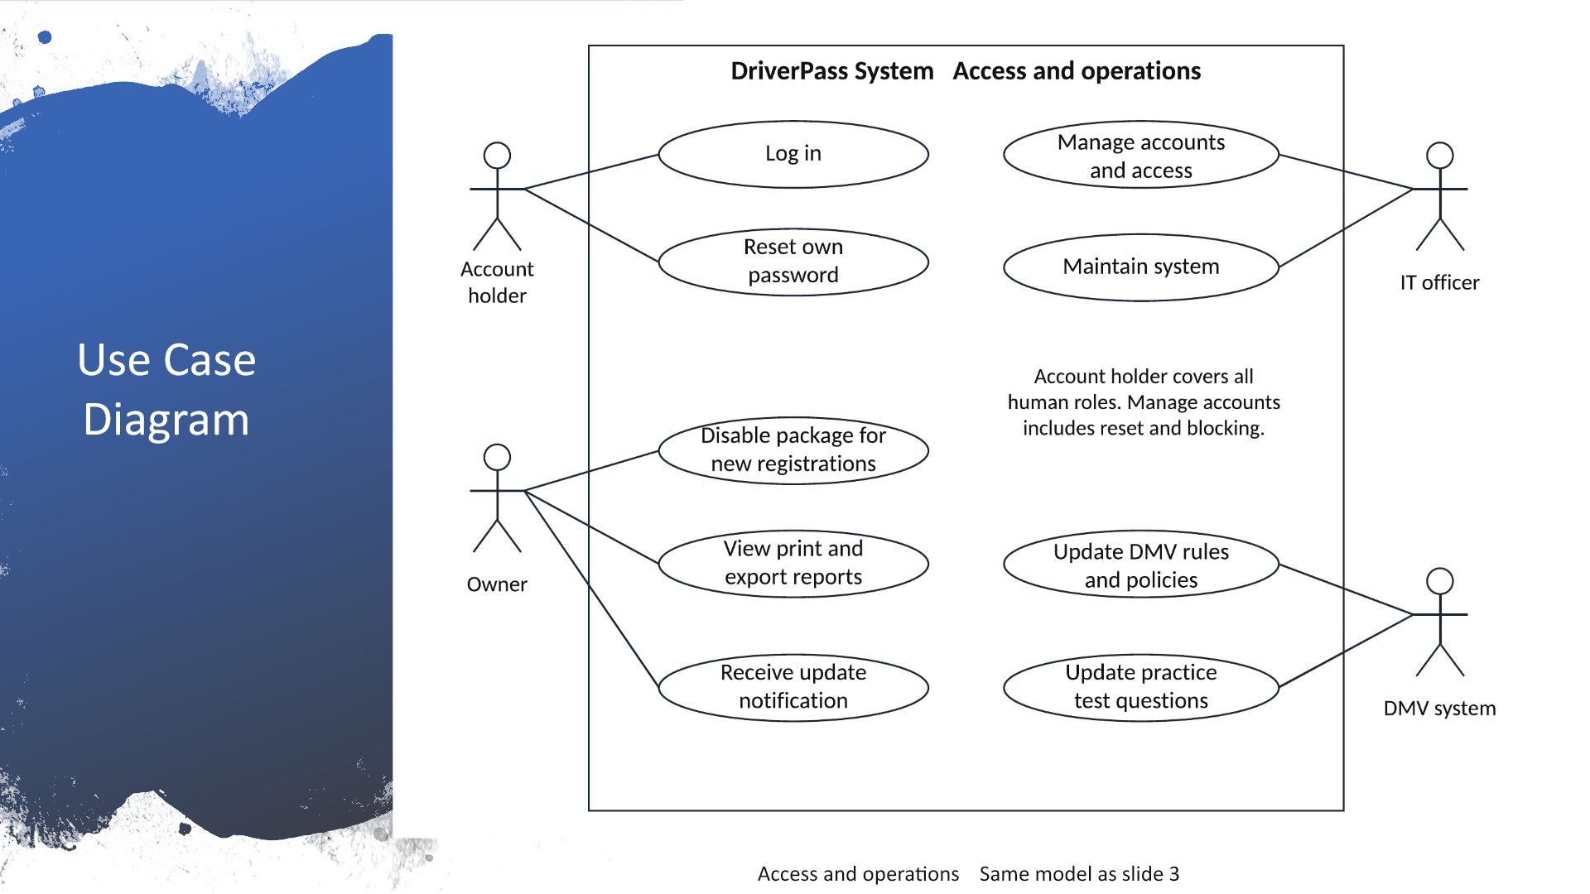

Speaker notes
This is the operations view of the same diagram. An account holder means any customer or staff member with an account using the sign-in and password-recovery services. Ian has separate account-management and maintenance functions. Liam can disable an existing package and review, print, or download reports. The DMV connects only to the two update services, for rules and policies and for practice-test questions. Receiving an update creates a notice for DriverPass. Authorized staff review the change before publishing new learning material, so a test already in progress keeps the version it started with. The specific DMV feed is an assumption to confirm. Source: DriverPass Interview Transcript, account management, reports, and DMV updates; Project One business requirements. Diagram source: revised UML model imported into Lucidchart, visually verified, and exported from Lucidchart. Editable source: https://lucid.app/lucidchart/a063bc40-1751-4ea4-9f02-ce56344cc82b/edit

